IPC

一、<https://github.com/emacski/tensorflow-serving-arm>

方法一： docker安装

方法二： 源码编译

docker安装

1、安装tfserving image

sudo docker pull emacski/tensorflow-serving:2.2.0-linux_arm

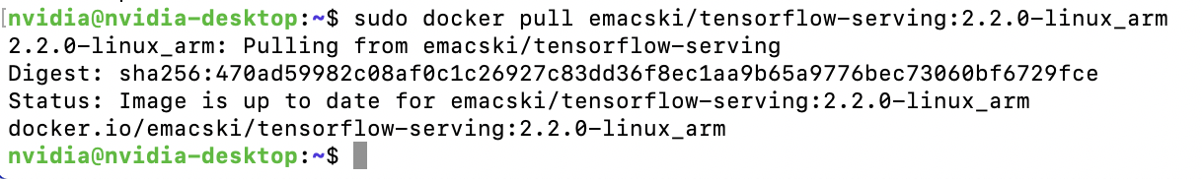

2、运行容器

sudo docker run -p 8501:8501 -v "$(pwd)/serving/tensorflow_serving/servables/tensorflow/testdata/saved_model_half_plus_three:/models/half_plus_three" -e MODEL_NAME=half_plus_three -t emacski/tensorflow-serving:2.2.0-linux_arm &

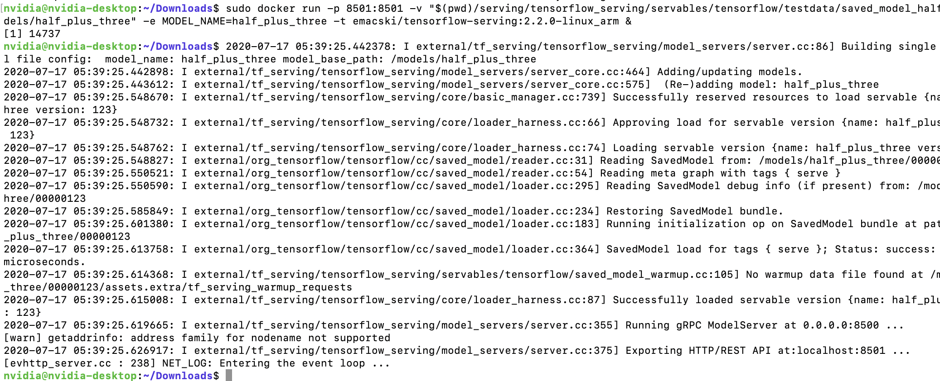

3、调用

curl -d '{"instances": [1.0, 2.0, 5.0]}' -X POST http://localhost:8501/v1/models/half_plus_three:predict



源码编译： 只提供了x86平台

<https://github.com/emacski/tensorflow-serving-arm#build-from-source>

二、<https://hub.docker.com/r/helmuthva/jetson-xavier-tensorflow-serving>

方法一：docker安装

1. 安装images

sudo docker pull helmuthva/jetson-xavier-tensorflow-serving:latest

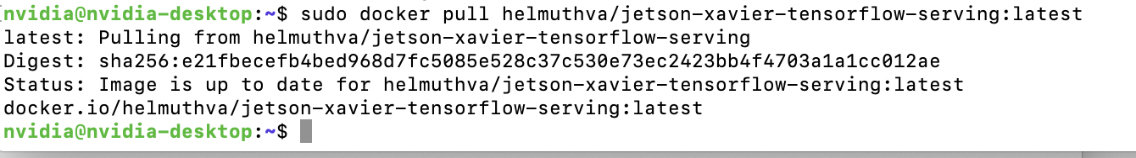

1. 运行容器

sudo docker run -p 8501:8501 -v "$(pwd)/serving/tensorflow_serving/servables/tensorflow/testdata/saved_model_half_plus_three:/models/half_plus_three" -e MODEL_NAME=half_plus_three -t helmuthva/jetson-xavier-tensorflow-serving:latest

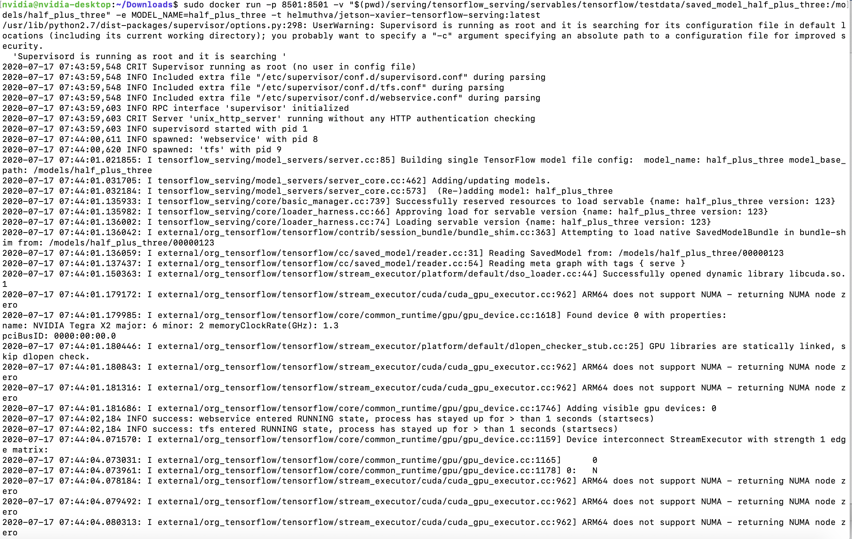

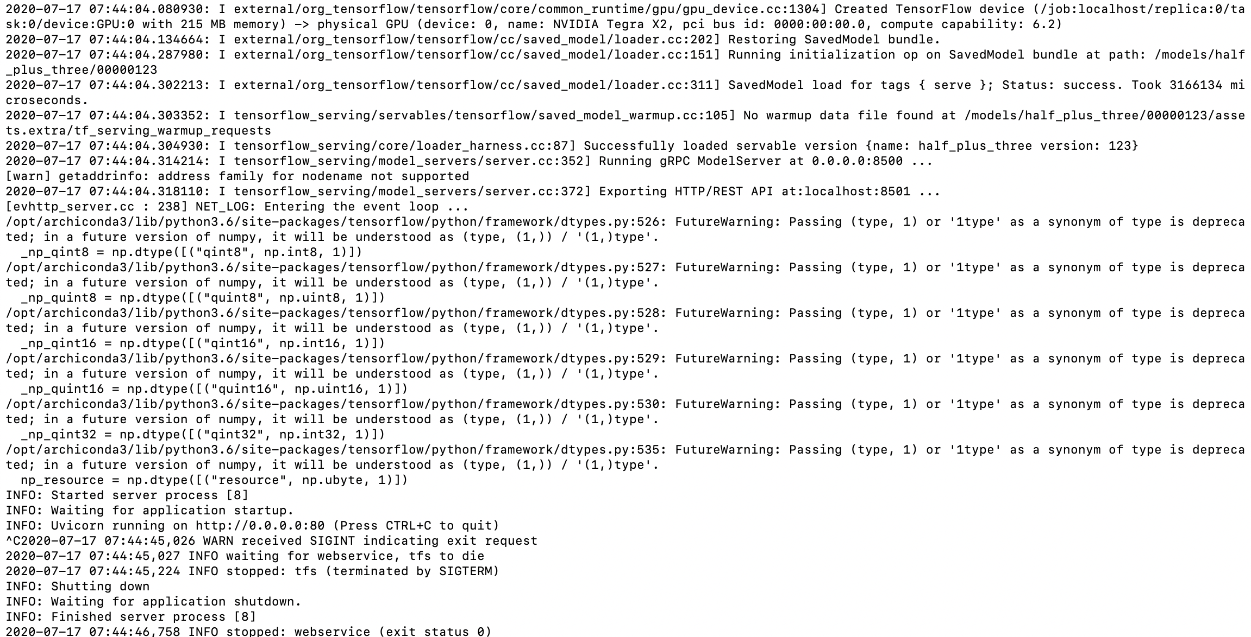

3、调用

curl -d '{"instances": [1.0, 2.0, 5.0]}' -X POST http://localhost:8501/v1/models/half_plus_three:predict

